Aircraft Design 1 – Fall 2025

Assignment 2: Preliminary & Propulsion Sizing

Student Names and USCIDs:

Aurelio Santiago, C30461119

Mateo Garcia, V02125756

Jacob Chin, C96554174

Instance 1

Hours spent on assignment: 1h

Aircraft type: Business Jet

Aircraft number: 110

Table : Requirements Table

|  |  |  |
| --- | --- | --- |
| Requirement Type | Value | Unit |
| Payload | 1100 | Kg |
| Range | 3600 | km |
| Cruise Altitude |  | m |
| Cruise Speed | 830 | km/hr |
| Take-off Distance | 1200 | m |
| Landing Distance | 860 | m |
| Propulsion System | jet |  |

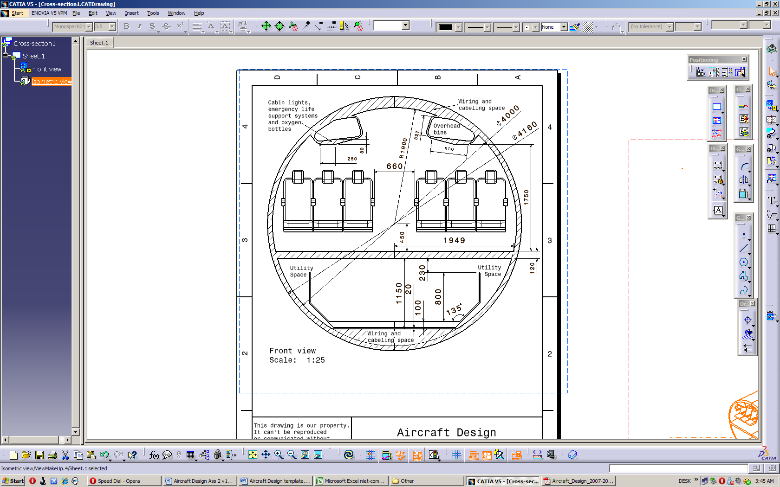

Table of Contents

1 – Introduction 4

2 -- Preliminary Sizing & Performance 5

2.1 – Fuel Fraction & Weight Estimation 5

2.2 – Sizing Graphs 5

3 -- Preliminary Engine Sizing 5

References: 6

Appendix 1: Additional Information 7

# 1 ­– Introduction

# 2 -- Preliminary Sizing & Performance

This section discusses the various components estimating fuel/payload weight and the bounds for propulsion and weight requirements/limits.

## 2.1 – Fuel Fraction & Weight Estimation

**2.1.1 – Non-Fuel Intensive Flight Section**

**2.1.2 – Fuel Intensive Flight Section**

**2.1.3 – Take-off Weight Estimation**

**2.1.4 – Total Weight Estimation**

## 2.2 – Sizing Graphs

# 3 -- Preliminary Engine Sizing

# References:

# Appendix 1: Additional Information